Research Guide: Expunging Your Criminal Record
Law Library for San Bernardino County
Research Guide, www.sblawlibrary.org, (909) 885-3020.

Disclaimer
The information in this research guide is intended to assist patrons with their legal research and is in no way intended to replace the counsel of an attorney. Any decisions about how to proceed must be determined by the patron. The library staff can recommend and refer you to print and web-based resources that will help you find answers to your law-related questions. The staff at the Law Library for San Bernardino County cannot explain or interpret the law, and we are not permitted to give legal advice.
What is an Expungement?
According the West’s California Digest, the term expungement is defined as,
“…the eradication of a record of conviction or adjudication upon the fulfillment of prescribed conditions…a redefinition of status, a process of erasing the legal event of conviction or adjudication and thereby restoring to the regenerative offender his status quo ante.” ¹
In other words, an expungement has the potential to re-open your criminal case in order for your conviction to be dismissed and possibly set aside. If your conviction is set aside, your case could be closed without the conviction. It is important to keep in mind that even though your record may be expunged, your criminal case record will still exist, and the expungement will appear if a criminal record check is conducted. Additionally, some parts of your sentence will remain unchanged and cannot be dismissed including the issuance of strikes, firearms prohibitions, and exclusions from serving jury duty. For more information on the expungement process, and what it may or may not do for you, refer to the resource guide titled Expunging Criminal Records: Step by Step that is provided by the Sacramento County Public Law Library at http://saclaw.com/pages/expunging-criminal-records.aspx or review some of the other print and electronic resource guides listed below.
Types of Expungement
Many people are not aware that there are three types of expungement. The first type of expungement is provided in Penal Code §1203.4. This type of expungement includes cases in which probation was ordered as part of the sentence.
The second type of expungement is available under Penal Code §1203.4(a). Expungement under this section should include cases in which probation was NOT ordered as part of the sentence.
Finally, the third type of expungement is listed under Penal Code §17. This type of expungement should reduce a felony conviction to a misdemeanor, after which, the misdemeanor could be dismissed. The following Dismissal forms are available online at www.courts.ca.gov/forms in a format you can fill out and print:
Petition for Dismissal (CR-180)
http://www.courts.ca.gov/documents/cr180.pdf
Order for Dismissal (CR-181)
http://www.courts.ca.gov/documents/cr181.pdf
Certificate of Rehabilitation
If you were sentenced to state prison, you may need to fill out and submit a Certificate of Rehabilitation, instead of the forms listed above. The Certificate of Rehabilitation is made under Penal Code § 4852.01, et.seq. For more information regarding the Certificate of Rehabilitation, you might want to review the California Criminal Defense Manual by Matthew Bender at the law library. Additionally, online information on this topic is provided by the California Department of Corrections and Rehabilitation below:
Certificate of Rehabilitation and Pardon Quick Reference for Restoration of Rights: http://www.cdcr.ca.gov/BOPH/docs/restoration_of_rights_reference.pdf
How to Apply for a Pardon: State of California, Office of the Governor, (Please see the bottom of page 2 of this guide.)
http://www.cdcr.ca.gov/BOPH/docs/apply_for_pardon.pdf
What Must I Do to Qualify for Expungement?
You must have successfully completed probation or you must have been discharged before the end of your probation sentence. See Penal Code §1203.4(a)
You may not be currently serving a sentence or be on probation for any other offense. See Penal Code §1203.4(a)
You cannot be charged with any further offenses. See Penal Code §1203.4(a)
You will not be eligible for expungement if you were sentenced to state prison, and there are certain offenses that cannot be expunged. Further, you will not be able to apply for expungement proceedings if you owe money for fines, fees, and restitution.
Will I Need a Copy of My Criminal Record Before Filing for an Expungement?
Before you file for the expungement process, you will need to obtain a copy of your criminal record. Case information will need to be obtained for each conviction you want to expunge. The case history sheet should include information that will be pertinent to filling out your expungement documents. You can request a copy of your criminal records from the State of California Justice Department at http://ag.ca.gov/fingerprints/security.php or you might want the review your options under the subheading Get a Copy of the Information on Your Criminal Record near the bottom of the page at http://www.courts.ca.gov/1070.htm

Court Fees
There will be a court fee for filing your documents with the court clerk. The filing fee is based on the type of conviction to be expunged. Fee waivers are available for low-income filers, and these forms can be found online at www.courts.ca.gov/forms and in print at the law library in the California Judicial Council Forms Manual. For additional information regarding court fees, you are encouraged to call the court clerk at the courthouse where your documents are being filing.
You might consider contacting the Public Defender’s Office for additional information or for assistance
with filling out your forms if they represented you in court. In San Bernardino County you can find contact information for the San Bernardino County Public Defender’s Office at http://www.sbcounty.gov/PublicDefender/Default.asp If you were represented by a public defender in a different county, please review the public defender links available on the California Public Defenders Association website at http://www.cpda.org/County/CountyPDWebSites.html for contact informtion.
Resource Guides for Expunging Your Criminal Record at the Law Library for San
Bernardino County
- California Criminal Defense Practice by Matthew Bender; KFC 1155 .C342, available at all branches
- California Criminal Law, 3rd edition by Witkin; KFC 1100 .W5, available at all branches
- California Criminal Law Forms Manual, 2nd edition by CEB; KFC 1155 .A65 C3424, available at all branches
- California Criminal Law Practice and Procedure by CEB; KFC 1155 A65 .C3424, available at all branches
- California Judicial Council Forms Manual; KFC 955 .A65 C34, available at all branches
- Criminal Law Handbook by Nolo Press; see staff at the reference desk, available at all branches
- Deerings California Codes Annotated; KFC 30.5 .D4, available at all branches
- Levenson on California Criminal Procedure; KFC 1155 .L475, available at the San Bernardino Branch only.
- West’s Annotated California Codes; KFC 30.5 .W4, available at all branches
Electronic Research Guides for Expunging Your Criminal Record
Cleaning Your Record Self-Help Guide
http://www.courts.ca.gov/1070.htm
Sacramento County Public Law Library
http://saclaw.com/pages/expunging-criminal-records.aspx
San Diego County Public Law Library Research Guide
http://www.sdcpll.org/resources/guides/Clean_Up_Your_Criminal_Record.pdf
Requesting Your Criminal Record
http://ag.ca.gov/fingerprints/security.php
¹ 55 West’s California Digest 2d, Words and Phrases, p. 304 (2005).
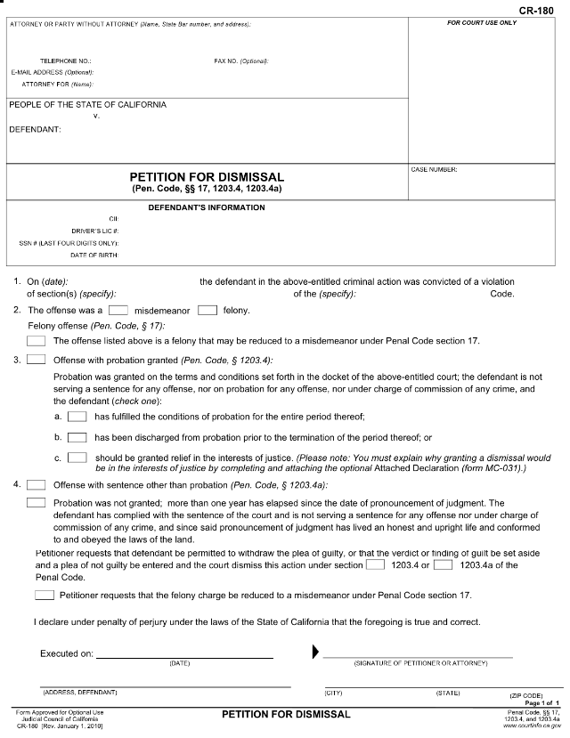
If probation was not part of your sentence, check this box.
Check here if probation was part of your sentence.
Your address information here
Your signature
Date petition signed
Check here if you felony conviction can be reduced to a misdemeanor under PC 17.
Check here if all the above statements are true in the paragraph.
If probation was part of your sentence, check here.
Enter the code section violated, e.g., 459.
Check here if probation was not part of your sentence.
Enter your name and address here.
Enter your phone number here.
Enter your case number in this box.
Enter the words, “In Pro Per” on the line that states “Attorney For (Name)”. This means you are representing yourself in this petition.
If your felony conviction may be reduced to a misdemeanor under PC 17, check this box.
Enter the code violated here, e.g., Penal.
Which box best describes your probation; a., b., or c.
The CII number is found on your DOJ Criminal Record printout in the top left hand corner. This is not a required entry. You will need to enter your driver’s license number, the last four digits of your social security number, and your date of birth.
Date of your conviction
For Felony Convictions
Check here for felony conviction.
In Pro Per
Penal
459
Enter your name here
459
Check misdemeanor conviction
Check here if probation was part of your sentence.
Enter the code violated here, e.g., Penal.
Check here if probation was not part of your sentence.
Check here if all the statements in the above paragraph are true.
If probation was not part of your sentence, check here.
Which box best describes your probation; a., b., or c.
If probation was part of your sentence, check here.
Enter the code section violated, e.g., 459.
Date of your conviction
Enter your name and address here.
Enter your phone number here.
Enter the words, “In Pro Per on the line that states “Attorney For (Name)”. This means you are representing yourself in this petition.
Enter your case number in this box.
The CII number is found on your DOJ Criminal Record printout in the top left hand corner. This is not a required entry. You will need to enter your driver’s license number, the last four digits of your social security number, and you date of birth.
Penal
Enter your name here.
In Pro Per
For Misdemeanor Convictions
Your address information here
Date petition signed
Your signature
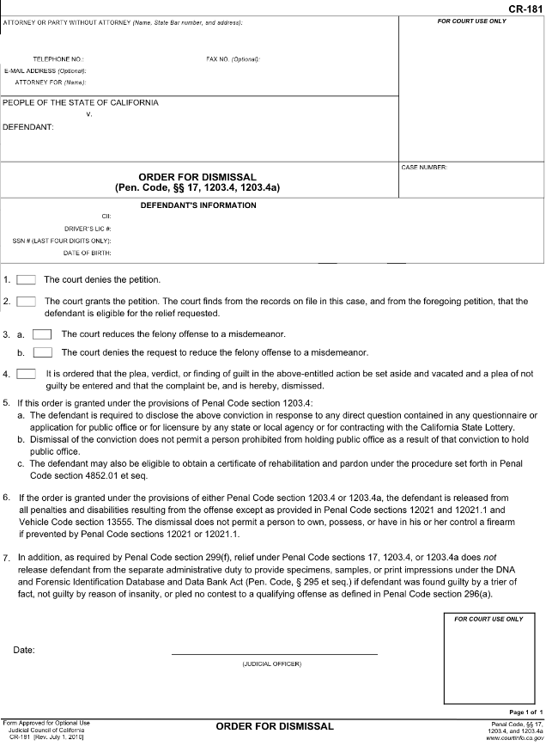
Enter the same information as presented on form CR-180.
DO NOT WRITE BELOW THIS LINE! This is where the judge will sign your petition.
Enter the words “In Pro Per” here. This means you are representing yourself in this petition.
Enter the case number of your conviction here.
Place your name, address and phone number here.
Your name here
In Pro Per

