Research Guide: Expunging Your Criminal Record
Law Library for San Bernardino County
Research Guide, www.sblawlibrary.org, (909) 885-3020.

Disclaimer
The information in this research guide is intended to assist patrons with their legal research and is in no way intended to replace the counsel of an attorney. Any decisions about how to proceed must be determined by the patron. The library staff can recommend and refer you to print and web-based resources that will help you find answers to your law-related questions. The staff at the Law Library for San Bernardino County cannot explain or interpret the law, and we are not permitted to give legal advice.
What is an Expungement?
An expungement has the potential to re-open your criminal case in order for your conviction to be dismissed and possibly set aside. If your conviction is set aside, your case could be closed without the conviction.
Will Expungement Remove a Conviction from My Record?
It is important to keep in mind that even though your record may be expunged, your criminal case record will still exist, and the expungement might appear if a criminal record check is conducted. Additionally, some parts of your sentence will remain unchanged and cannot be dismissed including the issuance of strikes, firearms prohibitions, and exclusions from serving jury duty. For more information on the expungement process, and what it may or may not do for you, refer to the resource guide titled Expunging Criminal Records: Step by Step that is provided by the Sacramento County Public Law Library at http://www.saclaw.org/uploads/files/Step-by-Step/expungingcriminalrecords.pdf or review some of the other print and electronic resource guides listed below.
Types of Expungement
There are three types of expungement. The first type of expungement is provided in Penal Code §1203.4. This type of expungement includes cases in which probation was ordered as part of the sentence.
The second type of expungement is available under Penal Code §1203.4(a). Expungement under this section should include cases in which probation was NOT ordered as part of the sentence.
The third type of expungement is listed under Penal Code §17. This type of expungement should reduce a felony conviction to a misdemeanor, after which, the misdemeanor could be dismissed. The following dismissal forms are available online at www.courts.ca.gov/forms in a format you can fill out and print:
Petition for Dismissal: CR-180
http://www.courts.ca.gov/documents/cr180.pdf
Order for Dismissal: CR-181
http://www.courts.ca.gov/documents/cr181.pdf
Certificate of Rehabilitation
If you were sentenced to state prison, you may need to fill out and submit a Certificate of Rehabilitation, instead of the forms listed above. The Certificate of Rehabilitation is made under Penal Code § 4852.01, et. seq. For more information regarding the Certificate of Rehabilitation, you might want to review the California Criminal Defense Manual by Matthew Bender at the law library. Additional online information regarding the Certificate of Rehabilitation is provided below:
Certificate of Rehabilitation and Pardon Quick Reference for Restoration of Rights: http://www.cdcr.ca.gov/boph/docs/restoration_of_rights_reference.pdf
How to Apply for a Pardon: State of California, Office of the Governor:
http://gov.ca.gov/s_pardonsandcommutations.php

What Must I Do to Qualify for Expungement?
- You should have successfully completed probation or you must have been discharged before the end of your probation sentence. See Penal Code §1203.4(a)

- You may not be currently serving a sentence or be on probation for any other offense. See Penal Code §1203.4(a)
- You cannot be charged with any further offenses. See Penal Code §1203.4(a)
- You will not be eligible for expungement if you were sentenced to state prison, and there are certain offenses that cannot be expunged. Further, you will not be able to apply for expungement proceedings if you owe money for fines, fees, and restitution.
Will I Need a Copy of My Criminal Record Before Filing for an Expungement?
Before you file for the expungement process, you will need to obtain a copy of your criminal record. You will need to obtain case information for each conviction you want to expunge. The case history sheet should include information that will be pertinent to filling out your expungement documents.

How Do I Obtain a Copy of My Criminal Record?
You can request a copy of your criminal records from the State of California Justice Department at http://ag.ca.gov/fingerprints/security.php or you might want the review your options under the subheading Get a Copy of the Information on Your Criminal Record near the bottom of the page at http://www.courts.ca.gov/1070.htm . When you file your original documents, an original Proof of Service needs to be included in your packet showing that copies of all documents were served to the District Attorney’s Office.
Where Do I File My Expungement Petition?
You will need to file your petition in the Superior Court for the county where you were convicted.
Court Fees
You will need to pay a court filing fee when you take your documents to the court clerk. The filing fee is based on the type of conviction to be expunged. For additional information regarding filing fees, you are encouraged to call the court clerk at the courthouse where your documents are being filed.
What if I Fill Out the Forms Incorrectly?
If you fill out your forms incorrectly, they will be returned to you. Occasionally, there will be an explanation as to what is incorrect on your forms. You may correct your forms and return it to the court without an additional filing fee.
If My Conviction Is Expunged, Can I Answer "No" to Questions about Convictions on Job applications?
Legally, you may answer "No" to these types of questions, but keep in mind that background checks typically go back ten years, so employers might see you had a conviction dismissed. Answering "No" on an application may look dishonest.

Your conviction could be discovered during a standard background check when applying for a government job, a job that requires security clearance, or a job that requires a government-issued license, certificate, or permit. You might want to disclose your conviction and expungement in these situations and you must disclose your conviction and expungement when applying for a government-issued license, certificate, or permit.
Additional Information and Resources
You might consider contacting the Public Defender’s Office for additional information or for assistance
with filling out your forms if they represented you in court. In San Bernardino County, you can find contact information for the San Bernardino County Public Defender’s Office at http://www.sbcounty.gov/PublicDefender/Default.asp

What if I Was Convicted in Another County?
If you were represented by a public defender in a different county, please contact the public defender office in that county for additional information regarding their services.

Resource Guides for Expunging Your Criminal Record at the Law Library for San
Bernardino County
- California Criminal Defense Practice by Matthew Bender; KFC 1155 .C342, available at all branches
- California Criminal Law, 3rd edition by Witkin; KFC 1100 .W5, available at all branches
- California Criminal Law Forms Manual, 2nd edition by CEB; KFC 1155 .A65 C3424, available at all branches
- California Criminal Law Practice and Procedure by CEB; KFC 1155 A65 .C3424, available at all branches
- California Judicial Council Forms Manual; KFC 955 .A65 C34, available at all branches
- Criminal Law Handbook by Nolo Press; see staff at the reference desk, available at all branches
- Deerings California Codes Annotated; KFC 30.5 .D4, available at all branches
- Levenson on California Criminal Procedure, KFC 1155 .L475, available at the San Bernardino Branch only.
- West’s Annotated California Codes; KFC 30.5 .W4, available at all branches
Electronic Research Guides for Expunging Your Criminal Record
Cleaning Your Record Self-Help Guide
http://www.courts.ca.gov/1070.htm
California Courts Judicial Council Forms
www.courts.ca.gov/forms
Requesting Your Criminal Record
http://ag.ca.gov/fingerprints/security.php
Sacramento County Public Law Library
http://www.saclaw.org/uploads/files/Step-by-Step/expungingcriminalrecords.pdf
San Diego County Public Law Library Research Guide
http://sandiegolawlibrary.org/wp-content/uploads/2013/04/Clean_Up_Your_Criminal_Record.pdf

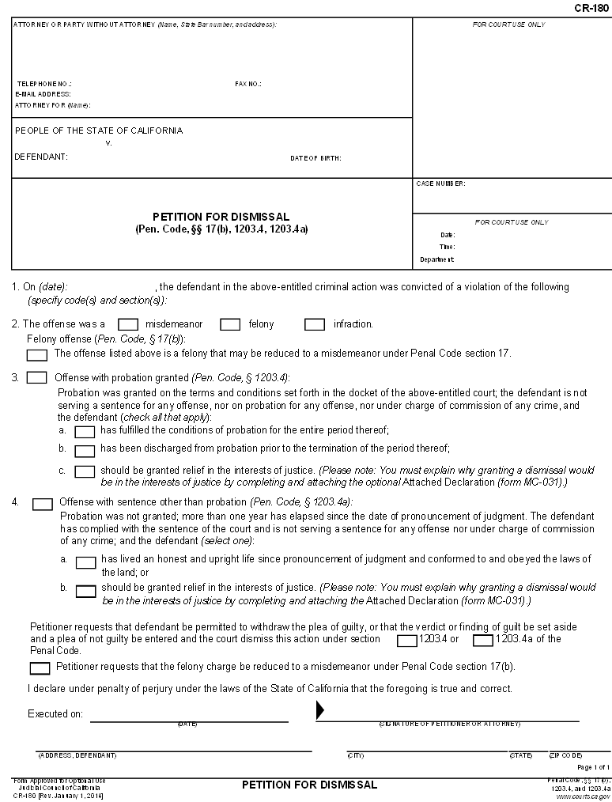
If your felony conviction may be reduced to a misdemeanor under PC 17, check this box.
Check box a or b. Select one box only.

Check here if all the statements are true in this paragraph, and you were not granted probation.
Enter your name and address here
Enter your case number here
Date petition signed
Your signature
Date of your conviction
Enter your name here
In Pro Per
For Felony Convictions
Check here if probation was part of your sentence.

Check here if probation was not part of your sentence.
Your address information
Check here if your felony conviction can be reduced to a misdemeanor under PC 17.
Check the box that best describes your probation; a, b, or c.
If probation was part of your sentence, check here.
Enter the code name & section number violated here, e.g. Penal Code, Section 459.
Check here for felony conviction
Enter the words, “In Pro Per” on the line that states “Attorney for (Name)”. This means you are representing yourself in this petition.

If probation was part of your sentence, check here.

If probation was granted, check the box that best describes your probation.

Date petition signed
Enter the code name & section number violated here, e.g. Penal Code, Section 459.

Check here if all the statements are true in this paragraph, and you were not granted probation.
Check box a or b. Select one box only.

Check here if probation was not part of your sentence.

Check here if probation was part of your sentence.
Check misdemeanor conviction
Enter your name here.
Your address information here
Your signature
Date of your conviction
Enter the words, “In Pro Per” on the line that states “Attorney for (Name)”. This means you are representing yourself in this petition.

In Pro Per
Enter your name and address here
Enter your case number here.
For Misdemeanor Convictions
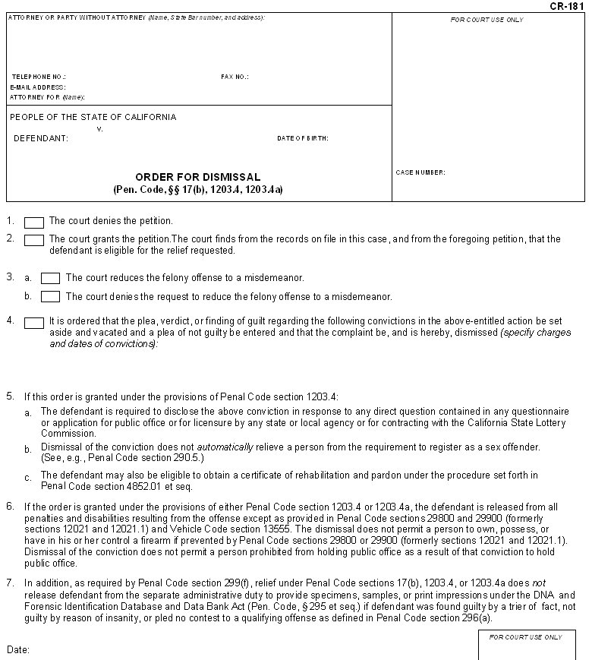
DO NOT WRITE BELOW THIS LINE!
The area below this line is for the judge to complete.
Enter your case number here.

In Pro Per
Enter the words, “In Pro Per” on the line that states “Attorney for (Name)”. This means you are representing yourself in this petition.

Enter your name and address here

