Research Guide: Petition for Dismissal
Law Library for San Bernardino County
Research Guide, www.sblawlibrary.org, (909) 885-3020. Updated as of May 2015.
Our Guide is adapted from the Sacramento County Law Library’s Guide on Expunging Criminal Records available at www.saclaw.org

Disclaimer
The information in this research guide is intended to assist patrons with their legal research and is in no way intended to replace the counsel of an attorney. Any decisions about how to proceed must be determined by the patron. The library staff can recommend and refer you to print and web-based resources that will help you find answers to your law-related questions. The staff at the Law Library for San Bernardino County cannot explain or interpret the law, and we are not permitted to give legal advice.
Is a Dismissal the same as an Expungement?
The court no longer provides expungements in which a conviction is removed from your criminal record. The courts now provide for a different procedure called a petition for Dismissal however it is still commonly referred to as an expungement.
What is a Petition for Dismissal?
The Petition for Dismissal is a process that allows you to clean up your criminal record. The Petition will reopen your criminal case and allows you to withdraw the plea or guilty verdict, dismiss the charges, and re-close the case without a conviction.
Will the Petition for Dismissal Remove a Conviction from My Record?
No. The conviction will still appear on your criminal record but the record will now note that the conviction was dismissed. Additionally, some parts of your sentence will remain unchanged and cannot be dismissed including the issuance of strikes, firearms prohibitions, and exclusions from serving jury duty.
For more detailed information on the process, and what it may or may not do for you, refer to the resource guide titled Expunging Criminal Records: Step by Step that is provided by the Sacramento County Public Law Library at http://www.saclaw.org/uploads/files/Step-by-Step/expungingcriminalrecords.pdf or review some of the other print and electronic resource guides listed below.
How Does the Petition for Dismissal Benefit Me? The Dismissal Will…
- Remove the conviction from your criminal history. California and FBI criminal history records will still show the conviction and the subsequent dismissal.
- Seal the court case file from public inspection. The court file remains public record.
- Reinstate your right to possess firearms. In some cases, reduction of a nonviolent felony to a misdemeanor may accomplish this.
- Relieve you of your duty to register as a sex offender. In some cases, this may be accomplished by a different motion to the court.
- Allow you to omit the conviction from applications for government-issued licenses. You must disclose your conviction and dismissal in your license application.
- Allow you to omit the conviction from application for government employment. If you are applying for a government job, a job that requires security clearance, or a job that requires a government-issued license, certificate, or permit, you must disclose the conviction and dismissal.
- Allow you to hold public office, if the conviction prevented you from doing so.
- Prevent the conviction from being used to refuse or revoke a government license or permit, such as real estate license, teaching credential, security guard certificate, etc.
- Prevent the conviction from being used as a "prior." The dismissed conviction can be used for determining sentencing enhancements in subsequent convictions.
- Prevent the conviction from being used by the DMV. Expunged convictions may be used to suspend or revoke driving privileges.
- Prevent the conviction from being used by US Citizenship and Immigration Services. In many situations, an expunged conviction may be considered for removal or exclusion purposes.
Types of Dismissal
There are various types of dismissal. The first type of dismissal is provided in Penal Code §1203.4. This type of dismissal includes cases in which probation was ordered as part of the sentence.
The next type of dismissal is available under Penal Code §1203.4(a). Dismissal under this section should include cases in which probation was NOT ordered as part of the sentence.
The next type of dismissal is listed under Penal Code §17. This type of dismissal should reduce a felony conviction to a misdemeanor, after which, the misdemeanor could be dismissed. The following dismissal forms are available online at www.courts.ca.gov/forms in a format you can fill out and print:
Petition for Dismissal: CR-180
http://www.courts.ca.gov/documents/cr180.pdf
Order for Dismissal: CR-181
http://www.courts.ca.gov/documents/cr181.pdf
Attached Declaration (if included): MC-031
http://courts.ca.gov/documents/mc031.pdf

Certificate of Rehabilitation
If you were sentenced to state prison, you may need to fill out and submit a Certificate of Rehabilitation, instead of the forms listed above. The Certificate of Rehabilitation is made under Penal Code § 4852.01, et. seq. For more information regarding the Certificate of Rehabilitation, you might want to review the California Criminal Defense Manual by Matthew Bender at the law library. Additional online information regarding the Certificate of Rehabilitation is provided below:

Certificate of Rehabilitation and Pardon Quick Reference for Restoration of Rights: http://www.cdcr.ca.gov/boph/docs/restoration_of_rights_reference.pdf
How to Apply for a Pardon: State of California, Office of the Governor:
http://gov.ca.gov/s_pardonsandcommutations.php

What Must I Do to Qualify for a Petition for Dismissal?
- You should have successfully completed probation or you must have been discharged before the end of your probation sentence. See Penal Code §1203.4(a)

- You may not be currently serving a sentence or be on probation for any other offense. See Penal Code §1203.4(a)
- You cannot be charged with any further offenses. See Penal Code §1203.4(a)
- You will not be eligible for dismissal if you were sentenced to state prison, and there are certain offenses that cannot be dismissed. Further, you will not be able to apply for dismissal proceedings if you owe money for fines, fees, and restitution.
Will I Need a Copy of My Criminal Record Before Filing for a Dismissal?
Before you file for the dismissal process, you will need to obtain a copy of your criminal record. You will need to obtain case information for each conviction you want to dismiss. The case history sheet should include information that will be pertinent to filling out your dismissal documents.
How Do I Obtain a Copy of My Criminal Record?
You can request a copy of your criminal records from the State of California Justice Department at http://ag.ca.gov/fingerprints/security.php or you might want the review your options under the subheading Get a Copy of the Information on Your Criminal Record near the bottom of the page at http://www.courts.ca.gov/1070.htm . When you file your original documents, an original Proof of Service needs to be included in your packet showing that copies of all documents were served to the District Attorney’s Office.
Where Do I File My Petition for Dismissal?
You will need to file your petition in the Superior Court in the county where you were convicted.
Court Fees
You will need to pay a court filing fee when you take your documents to the court clerk. The filing fee is based on the type of conviction to be dismissed. For additional information regarding filing fees, you are encouraged to call the court clerk at the courthouse where your documents are being filed.
What if I Fill Out the Forms Incorrectly?
If you fill out your forms incorrectly, they will be returned to you. Occasionally, there will be an explanation as to what is incorrect on your forms. You may correct your forms and return it to the court without an additional filing fee.
If My Conviction Is Dismissed, Can I Answer "No" to Questions about Convictions on Job applications?
Legally, you may answer "No" to these types of questions, but keep in mind that background checks typically go back ten years, so employers might see you had a conviction dismissed. Answering "No" on an application may look dishonest.

Your conviction could be discovered during a standard background check when applying for a government job, a job that requires security clearance, or a job that requires a government-issued license, certificate, or permit. You might want to disclose your conviction and dismissal in these situations and you must disclose your conviction and dismissal when applying for a government-issued license, certificate, or permit.
Do I have to file a Petition for Each Conviction?

You will need to complete a separate Petition for Dismissal (CR-180) and Order for Dismissal (CR-181) for each conviction you wish to dismiss. (Each conviction may consist of convictions for multiple offenses).

Additional Information and Resources
You might consider contacting the Public Defender’s Office for additional information or for assistance
with filling out your forms if they represented you in court. In San Bernardino County, you can find contact information for the San Bernardino County Public Defender’s Office at http://www.sbcounty.gov/PublicDefender/Default.asp
What if I Was Convicted in Another County?
If you were represented by a public defender in a different county, please contact the public defender office in that county for additional information regarding their services.

Resource Guides for Cleaning Up Your Criminal Record at the Law Library for San
Bernardino County
- California Criminal Defense Practice by Matthew Bender; KFC 1155 .C342, available at all branches
- California Criminal Law, 3rd edition by Witkin; KFC 1100 .W5, available at all branches
- California Criminal Law Forms Manual, 2nd edition by CEB; KFC 1155 .A65 C3424, available at all branches
- California Criminal Law Practice and Procedure by CEB; KFC 1155 A65 .C3424, available at all branches
- California Judicial Council Forms Manual; KFC 955 .A65 C34, available at all branches
- Criminal Law Handbook by Nolo Press; see staff at the reference desk, available at all branches
- Deerings California Codes Annotated; KFC 30.5 .D4, available at all branches
- Levenson on California Criminal Procedure, KFC 1155 .L475, available at the San Bernardino Branch only.
- West’s Annotated California Codes; KFC 30.5 .W4, available at all branches
Electronic Research Guides for Expunging Your Criminal Record
Cleaning Your Record Self-Help Guide
http://www.courts.ca.gov/1070.htm
California Courts Judicial Council Forms
www.courts.ca.gov/forms
Requesting Your Criminal Record
http://ag.ca.gov/fingerprints/security.php
Sacramento County Public Law Library
http://www.saclaw.org/uploads/files/Step-by-Step/expungingcriminalrecords.pdf
San Diego County Public Law Library Research Guide
http://sandiegolawlibrary.org/wp-content/uploads/2013/04/Clean_Up_Your_Criminal_Record.pdf
How Do I File a Petition for Dismissal?
Step 1: Decided whether you qualify for the Petition for Dismissal. See above.
Step 2: Determine which type of Dismissal applies to you.
The type of dismissal used depends on the original conviction and sentence. The information below will help you determine which type of dismissal is right for you. Misdemeanor or Infraction Convictions.
- Probation ordered and completed: File a Petition for Dismissal under PC § 1203.4.

- Probation ordered, but not yet completed: File a Motion to Terminate Probation (see the Step-by-Step guide on filing a Motion to Terminate Probation on our website http://www.sblawlibrary.org/research-guides--self-help-info.html). If that is granted, file a Petition for Dismissal under PC § 1203.4.

- Probation not ordered: File a Petition for Dismissal under PC § 1203.4a. Felony Convictions.

- County Jail and/or Probation ordered and completed: File a Petition under PC § 17(b)(3) to reduce the felony to a misdemeanor, and Petition for Dismissal under PC § 1203.4 to expunge the misdemeanor.

- Probation ordered, but not yet completed: File a Motion to Terminate Probation (see the Step-by-Step guide on filing a Motion to Terminate Probation on our website at http://www.sblawlibrary.org/research-guides--self-help-info.html). If that is granted, file a Petition under PC § 17(b) to reduce the felony to a misdemeanor, and Petition for Dismissal under PC § 1203.4 to expunge the misdemeanor.

- State Prison ordered but time served in county jail: File a Petition under PC § 1203.41.

- Other Situations: If you are not eligible for the procedures described in this guide, you may need to apply for a Certificate of Rehabilitation and/or a Pardon. More information is available from the California Department of Corrections and Rehabilitation at www.cdcr.ca.gov/BOPH/pardons.html.

Step 3: Obtain a Copy of Criminal Record. See above.
Step 4: Complete the Forms.
Petition for Dismissal (CR-180)
Order for Dismissal (CR-181)
Attached Declaration (MC-031)

The Declaration is your opportunity to tell the judge anything you think is relevant to them granting the petition, this may include any of the following:
- Your plans for the future.
- The reasons you offended, and how your life is different today than it was before.
- How the conviction has hurt your employment chances.
- If you have received any training or education since your conviction.
- Any 12-step or religious affiliations you have.
STEP 5: COPY AND ASSEMBLE YOUR DOCUMENTS

- Make three copies each of Petition for Dismissal (CR-180), Order for Dismissal (CR-181), Attached Declaration (MC-031).
- Assemble Proof that all fines, fees and restitution are paid in full.
- Processing fee or Fee Waiver forms (see Step 6).
- Self-addressed stamped envelope if you want a copy of the signed Order mailed to you.

STEP 6: FILE YOUR FORMS

Dismissal forms are filed in the county where you were convicted. For courthouse locations, see www.courts.ca.gov/superiorcourts.htm.

STEP 7: SERVE YOUR FORMS
Service is a formal way of giving copies of court documents to all parties in a case. In a dismissal proceeding, the District Attorney and Probation Department must be served. Some courts may serve the papers for you. If not you will need to have the papers served and fill out a proof of service. See San Bernardino Local Court Form SB 37 http://www.sb-court.org/Portals/0/Documents/PDF/Forms/SB-37.pdf

STEP 8: ATTEND YOUR COURT HEARING, IF REQUIRED

The following sample is provided to assist you with filing out the forms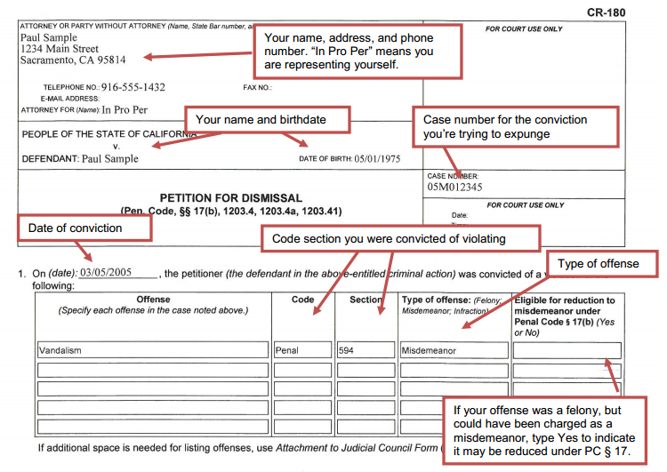
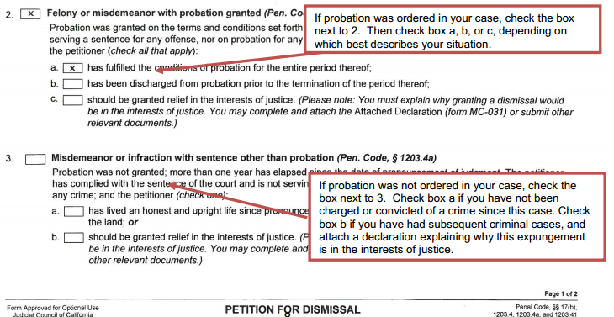

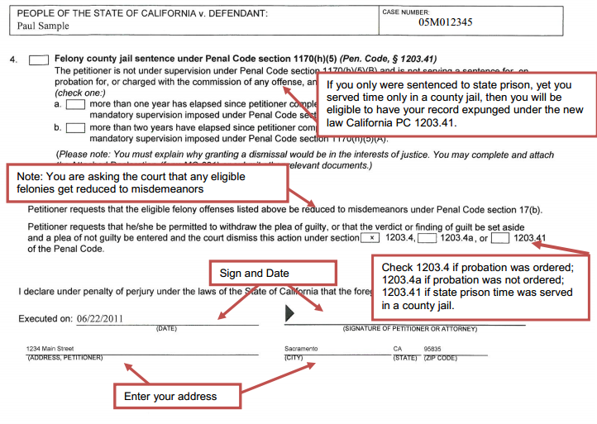

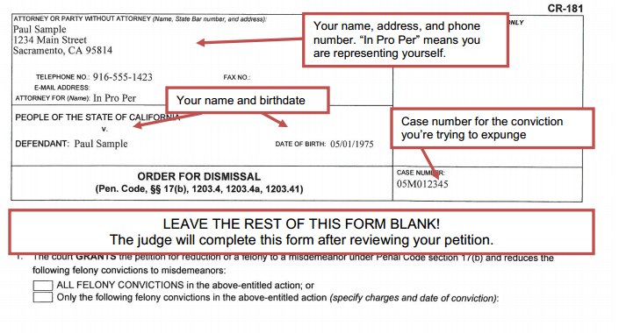

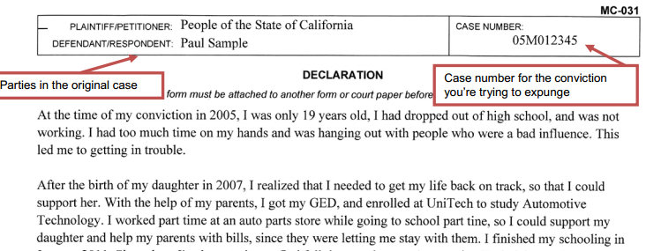
…..

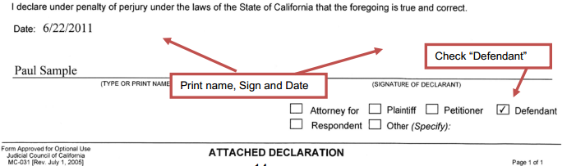
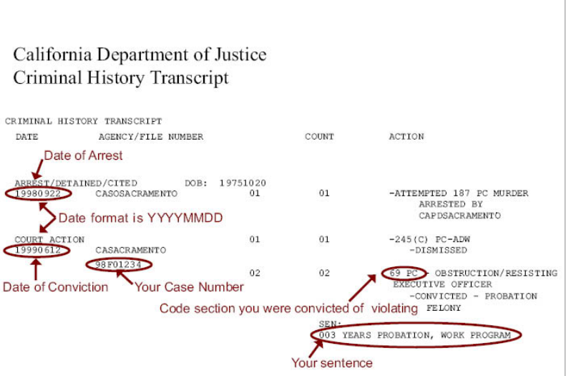

In addition to this guide the Law Library hosts a Criminal Record Expungement Informational & Legal Clinic. Hosted by the Inland Empire Latino Lawyers Association, Inc.,

Every Third Friday of the Month @ 10:00 AM

San Bernardino County Law Library
402 North D. Street, Mezzanine Level
San Bernardino, CA 92401

*This is an information session and clinic session. Come learn what expungement really means, if your convictions qualify, what to bring to begin the process and where to get it*

For more information, see their website IE Expungement Project
www.iellaaid.org (951) 369-3009

